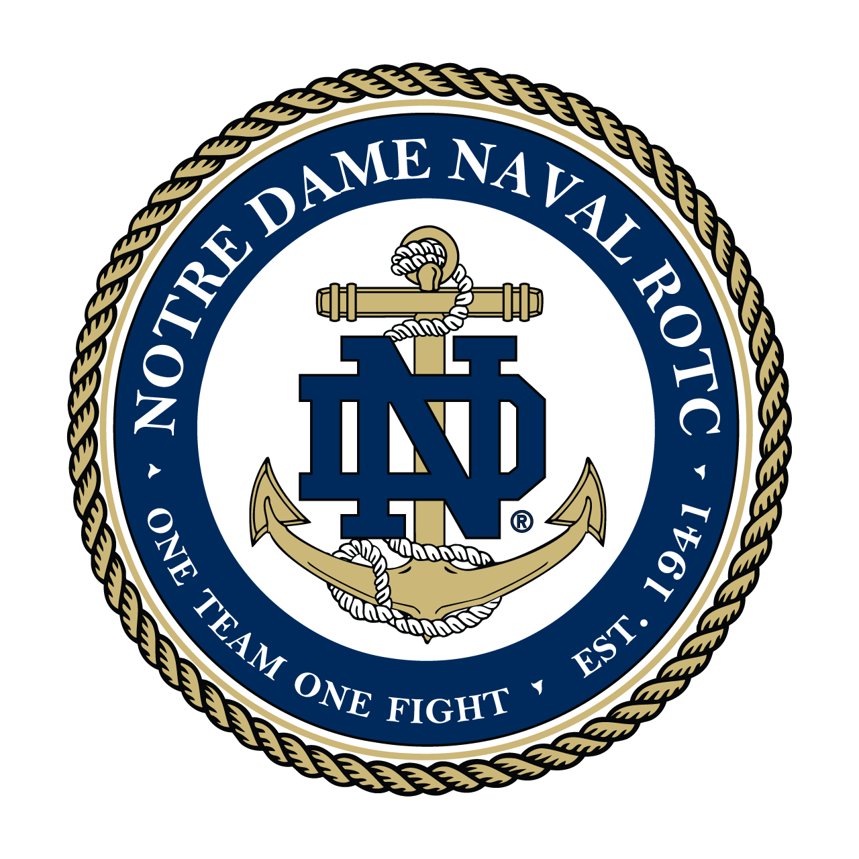

ASSESSMENTS

COMMANDING OFFICER

CAPTAIN MICHAEL B. RYAN, USN